***QUE-24.2-***

***INPUT FILE-***

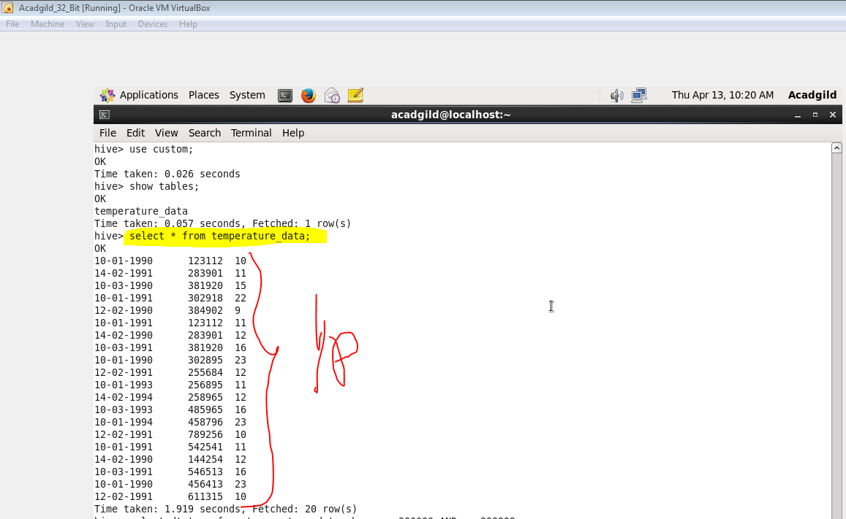

1. **Fetch date and temperature from temperature_data where zip code is greater than 300000 and less than 399999.**

***OUTPUT-***

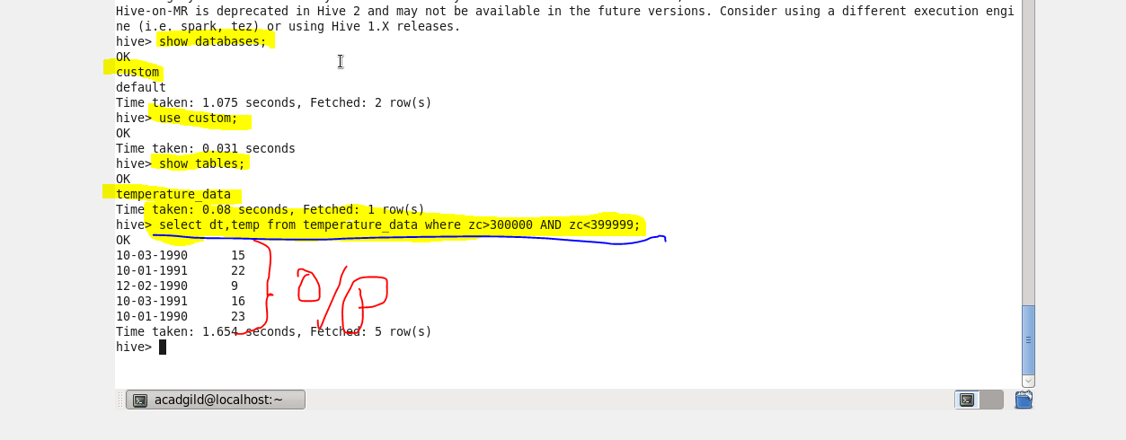

**2-** **Calculate maximum temperature corresponding to every year from temperature_data table.**

***OUTPUT-***

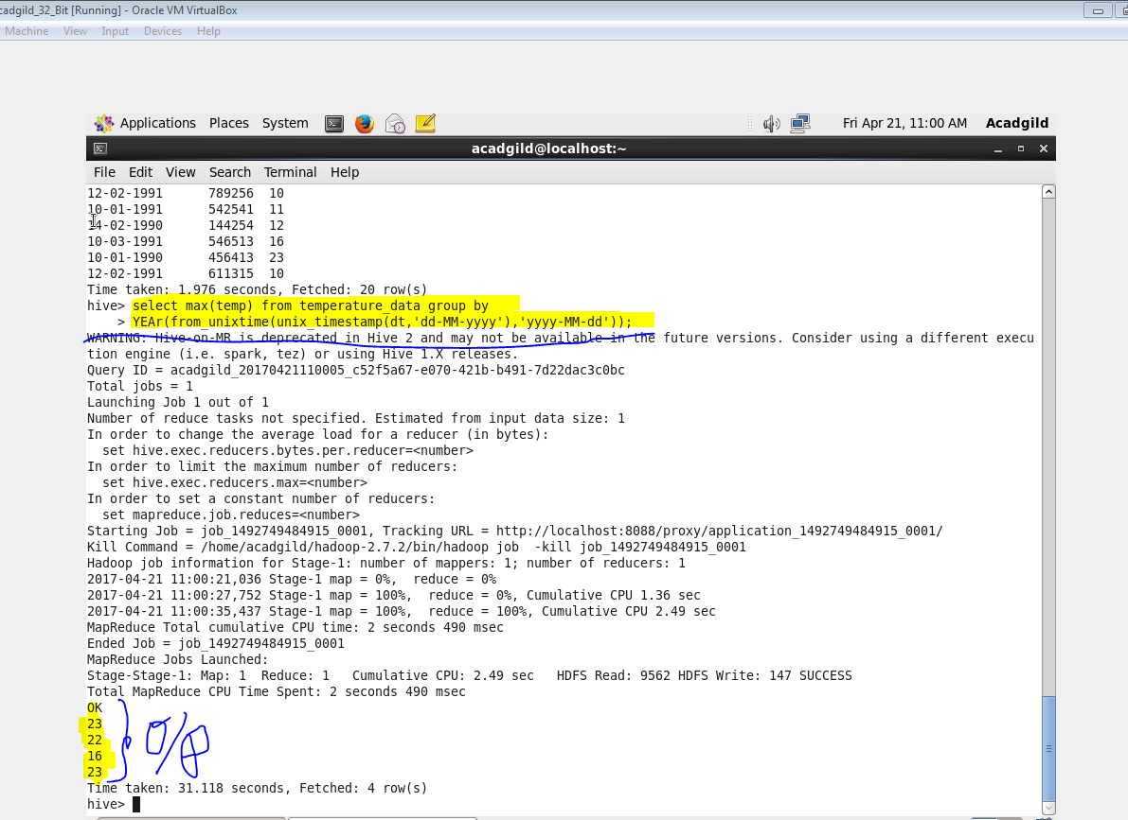

**3-Calculate maximum temperature from temperature_data table corresponding to those years which have at least 2 entries in the table.**

***OUTPUT-***

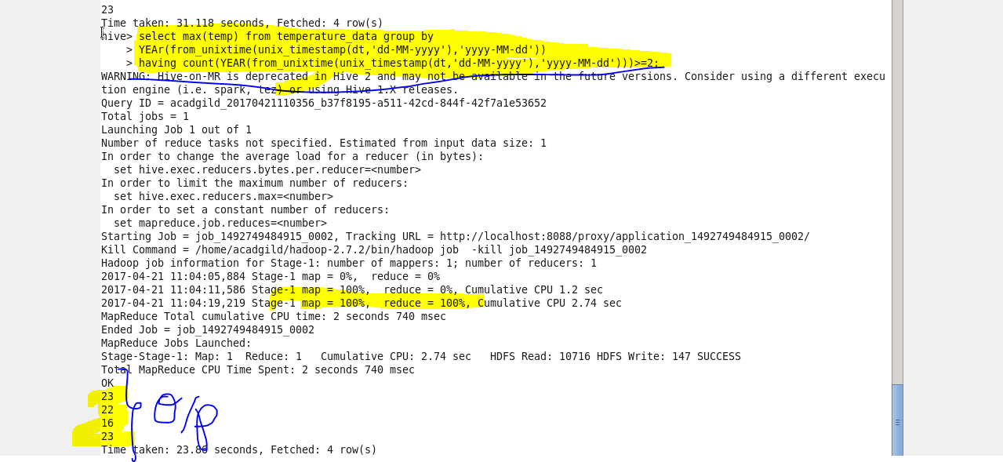

**4- Create a view on the top of last query, name it temperature_data_vw.**

***OUTPUT-***

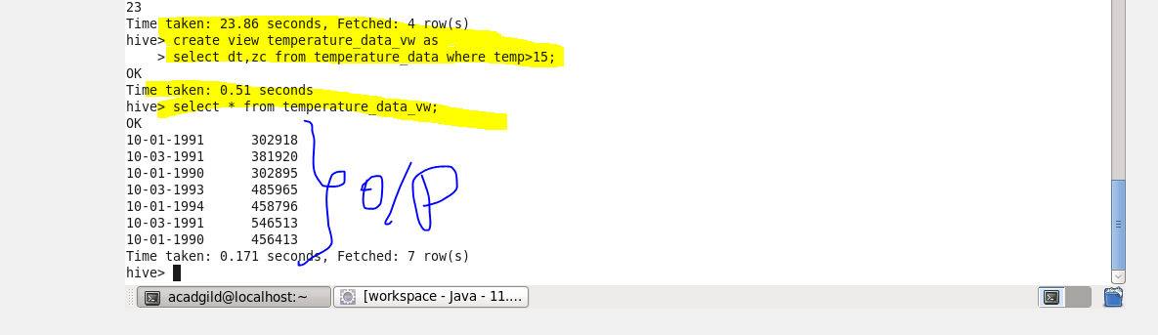

**5-Export contents from temperature_data_vw to a file in local file system, such that each file is '|' delimited**

***OUTPUT-***

